Technology Handout

Poll Everywhere:
Poll Everywhere is a web-based audience response system that allows you to gather live responses from your audience via laptops, tablets or mobile devices.

Today, we will be using Poll Everywhere for audience participation in the presentation.
To join, please use one of the following (this will allow you to participate in the poll once we reach that point in the presentation):
- Option One for laptops or tablets: PollEv.com/lindymayled560
- Option Two for smartphones: Text LINDYMAYLED560 to 37607 to join the session

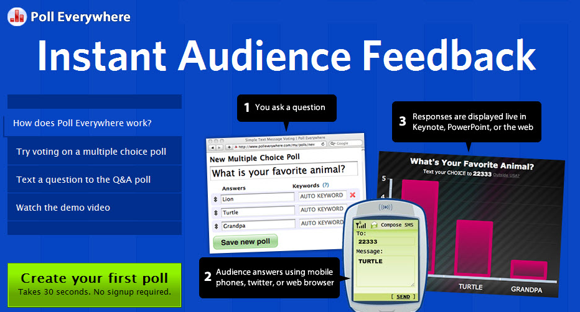

Linoit:
Linoit is a collaboration tool that allows students to share information on a virtual vision board. They can brainstorm ideas, share resources, and complete small assignments to demonstrate knowledge. You can post notes in return, peel their note off of the board if they have not correctly answered the question, or post additional resources (videos, websites, etc.) to assist with student questions.

Linoit activity:
With your partner to complete the following activity
- Think through a topic/lesson/learning objective that could be enhanced by using a technology tool or app (see list of possible resources or types of technology for inspiration)
- Briefly summarize how you could use a technology tool in your scenario
- Use Linoit to share your response: tinyurl.com/ASUFacultyws
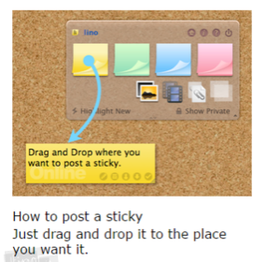

Resources and Additional Information
Tech Tools Summary Google Doc:
https://tinyurl.com/JTFDTechTools

All JTFD project materials, including readings, presentations, videos, participant handouts, and participant exercises can be found here:
https://tinyurl.com/JTFDMaterialsandResources

